**Study Guide - The Cell Cycle:**

**3 Stages of the Cell Cycle: Interphase, Mitosis and Cytokinesis**

**Interphase:** (90% of the cell life is spent in Interphase. It is growing, making a copy of its DNA and carrying out its cellular functions)

**Mitosis: (Prophase, Metaphase, Anaphase, Telophase) P.M.A.T.**

**Prophase:** The chromatin condenses and coils into chromosomes. The nuclear envelope (nucleus membrane) starts to dissolve.

**Metaphase:** The chromosomes line up along the center of the cell.

**Anaphase:** Spindle fibers pull the chromosomes to opposite ends of the cell.

**Telophase:** A new nuclear membrane forms around each group of chromosomes.

**Cytokinesis:** The cell membrane pinches or contracts, separating the cell into two. In plant cells, due to the cell wall being too tough to pinch, a Cell Plate forms down the center.

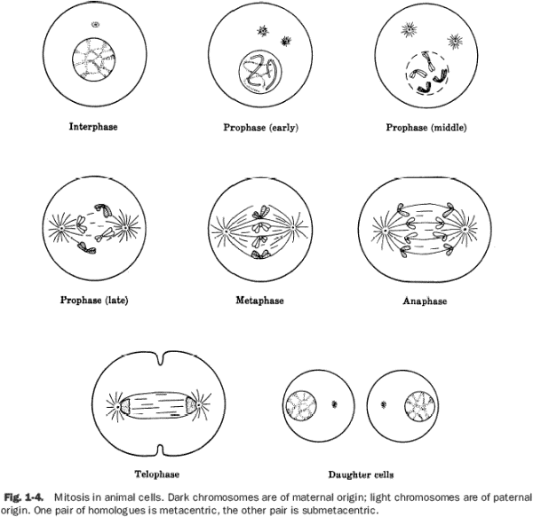

**Cancer:** The uncontrolled cell growth. The DNA inside the nucleus contains a mutation that causes the cell to divide uncontrollably. They are larger and abnormal and do not carry out the functions of healthy cells. Cancer cells crowd out healthy cells and prevent them from carrying out their regular functions.

Cancer spreads when cancerous cells break away from a cluster of cancer cells (tumor) and are carried by the bloodstream to another location where they attach to another part of the body and continue to divide and grow.

**Treatment:**

* + **Surgery (before cancer spreads, the cancer is surgically removed)**
  + **Radiation (High frequency waves target cancer cells and kill them)**
  + **Chemotherapy (medication which travels through the bloodstream and targets cancer cells)**